**Question 2:**

**Python Scripting:**

**Log file:**

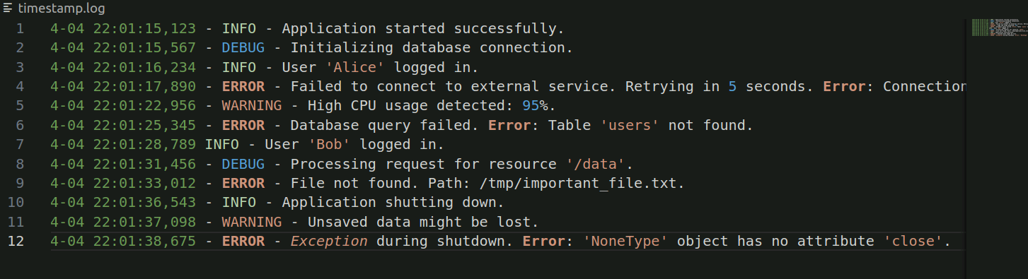

**Python code:**

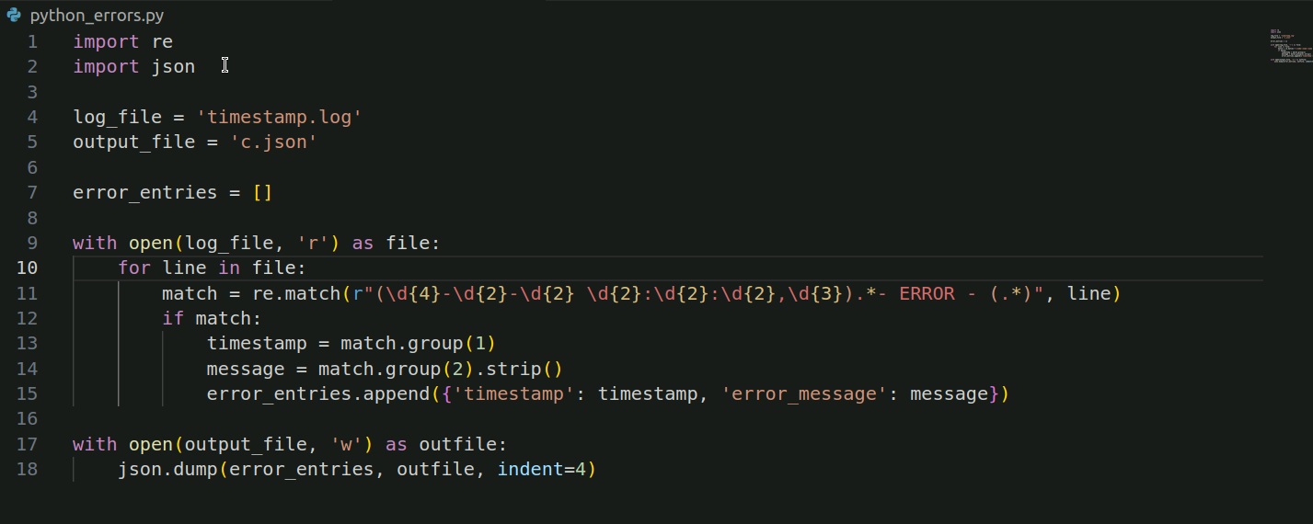

**c.json**

